**Test 1**

**Task1. You are going to read aloud. You have 1.5 minutes to read the text silently, and then be ready to read it aloud. Remember that you will not have more than 2 minutes for reading aloud.**

Many countries have a special day each year when they celebrate a “national day”.  This day is dedicated to the country’s founding or independence or even a special day for the ruler.  Usually these days are a national public holiday where everyone takes the day off from work.

America’s national day is called “Independence Day” and it is held every year on July 4.  This **marks** the signing of the famous **document**, The Declaration of Independence in 1776.  In France, the national day is on July 14.  This is the anniversary for the storming of the Bastille.  It is considered the start of the French Revolution.   Japan’s National Foundation Day is on February 11.  This is to honor the crowning of Jimmu, the first emperor long ago in 660 AD.

Some countries have several national days.  In Spain, for example, there are four national holidays.  However, a few countries do not have any national day.  This includes Denmark and the United Kingdom.  Recently, politicians in the United Kingdom hope for the **establishment** of a national day.

**Task2. You are going to take part in a telephone survey. You have to answer 6 questions. Give full answers to the questions. Remember that you have 40 seconds to answer each question.**

**Electronic assistant:** Hello! It’s the electronic assistant of the MEGA Shopping Mall. We kindly ask you to take part in our survey. We need to find out how people fell about shopping in our region. Please answer 6 questions. The survey is anonymous- you don’t have to give your name. So, let’s get started.

**Electronic assistant:** How old are you?

**Student:**

**Electronic assistant**: How many times a week do you do shopping?

**Student:**

**Electronic assistant:** What shops are the most popular with teenagers?

**Student:**

**Electronic assistant:** What shops and shopping malls are near your place?

**Student:**

**Electronic assistant:** What is your favourite shop and why?

**Student:**

**Electronic assistant:** What shops would you advise to visit?

**Student:**

**Task 3. You are going to have a talk about extreme sports. You will have to start in 1.5 minutes and speak for not more than 2minutes.**

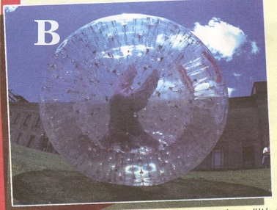

**Remember to say:**

* **Why people take extreme sports**
* **If you have ever tried this kind of sports**
* **What are the advantages and disadvantages in extreme sports**

**You have to talk continuously**